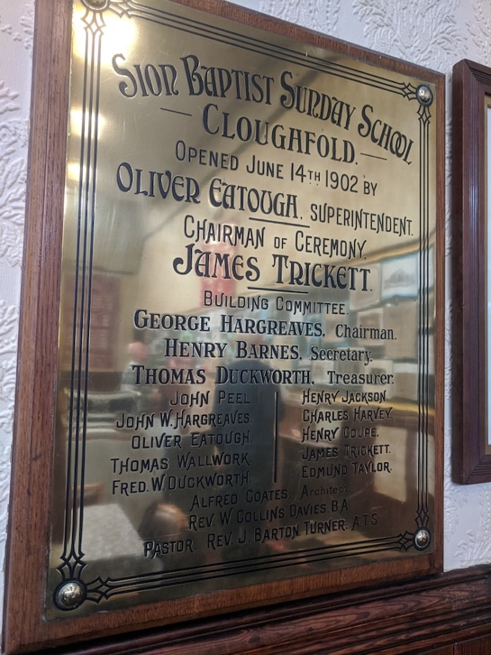

SION BAPTIST SUNDAY SCHOOL
CLOUGHFOLD
OPENED JUNE 14TH 1902 BY
OLIVER EATOUGH, SUPERINTENDENT

CHAIRMAN OF CEREMONY
JAMES TRICKETT

BUILDING COMMITTEE
GEORGE HARGREAVES Chairman
HENRY BARNES Secretary
THOMAS DUCKWORTH Treasurer

JOHN PEEL HENRY JACKSON
JOHN W HARGREAVES CHARLES HARVEY
OLIVER EATOUGH HENRY COUPE
THOMAS WALLWORK JAMES TRICKETT
FRED W DUCKWORTH EDMUND TAYLOR

ALFRED COATES Architect
REV W COLLINS DAVIES B.A.
PASTOR REV J BARTON TURNER ATS

