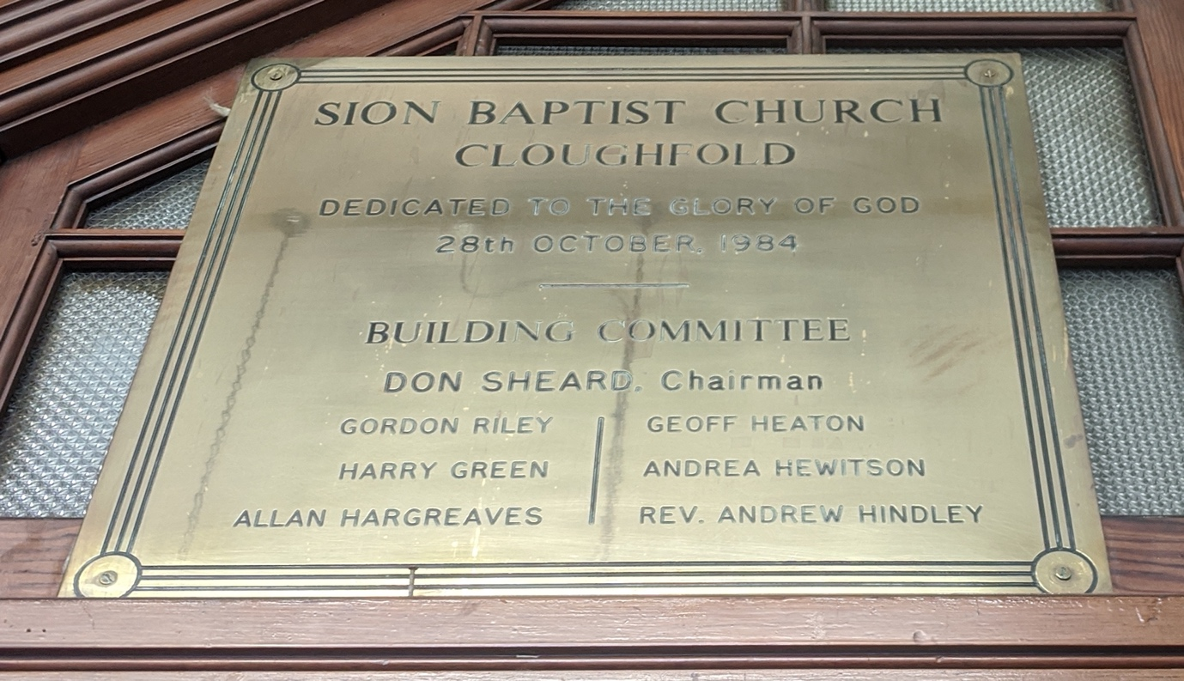

SION BAPTIST CHURCH
CLOUGHFOLD
DEDICATED TO THE GLORY OF GOD
28TH OCTOBER 1984

BUILDING COMMITTEE
DON SHEARD, Chairman

GORDON RILEY GEOFF HEATON
HARRY GREEN ANDREA HEWITSON
ALLAN HARGREAVES REV. ANDEW HINDLEY

