SION BAPTIST CHURCH, CLOUGHFOLD
1672-1972

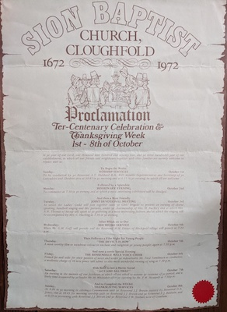

Proclamation
Ter-Centenary Celebrations and Thanksgiving Week

In ye year of our Lord, one thousand nine hundred and seventy two; and ye three hundredth year of our establishment; in which all our friends and neighbours together with their families are warmly welcome to rejoice with us.

To Begin the Weeke
WORSHIP SERVICES
Sunday: October 1st
To be conducted by ye Reverend A.T. Hubbard B.A. B.D, notable Superintendent and Secretary of ye Lancashire and Cheshire area at 10/45 in ye morning and at 6.15 in ye evening; to which all are welcome

Followed by a Splendide
MISSIONARY EVENING
Monday: October 2nd
To commence at 7.30 in ye evening and at which a most interesting exhibition will be divulged

And then a Most Friendly
JOINT DEVOTIONAL MEETING
Tuesday; October 3rd
At which the Ladies’ Guild will join together with ye Girls’ Brigade to present an evening of choral speaking, handbell ringing and like pursuits, under ye chairmanship of Mrs. H. Buckley and at which Mrs. A.W. Thomas of Bacup will speak to ye gathering in a most interesting fashion; and at which the singing will be accompanied by Mrs. C. Hacking at 7.30 in ye evening

After Which on to Our
MID WEEKE SERVICE
Wednesday; October 4th
When Mr G.M. Goff will preside and the Reverend W.H. Davies of Blackpool village will preach at 7.30 p.m.

Then Followes a Film Night for Young People
“THE DEVIL’S ELBOW”
Thursday; October 5TH
A most worthy film in wondrous colour to enchant and enlighten ye young people; again at 7.30 p.m.

And now a verrie Special Evening
THE ROSSENDALE MALE VOICE CHOIR
Friday; October 6th
Famed far and wide for their passion of voice and under ye redoubtable Mr Fred Tomlinson as conductor; a moderate charge of 10 new pence will admit to this most wonderful evening of song at 7.30 p.m.

With next to last a Merrie Social
“1672 AND ALL THAT”
Saturday: October 7th
An evening in the manner of our forebears at which all are asked to assume ye costume of ye period; and a lively time is assured by ye leader Mr. H. Whittaker after ye opening by Mr. F.W. Howarth at 7.30 p.m.

And to Compleat the WEEKE
THANKSGIVING SERVICES
Sunday; October 8th
At 9.30 in ye morning to celebrate Communion with ye Reverent J.J. Brown assisted by Reverend D.A. Jones; ant at 10:45 for morning worship with ye Reverend J.J. Brown and ye Reverend F.J. Baldwin; and at 6.15 in ye evening with Reverend j.J. Brown and ye Reverent T.W. Stobart now of Cranham

